**US Accidents Visualizations**

***By Somendra, Pablo and Balaji***

**Visualization 1:**

**SPICE:**

WITH sev1 as(SELECT DISTINCT count(id) as Acc_Sev1, state

FROM us_accidents_dec_19_database.us_accident_v3

WHERE severity = 1

GROUP BY state),

sev2 as(SELECT DISTINCT count(id) as Acc_Sev2, state

FROM us_accidents_dec_19_database.us_accident_v3

WHERE severity = 2

GROUP BY state),

sev3 as(SELECT DISTINCT count(id) as Acc_Sev3, state

FROM us_accidents_dec_19_database.us_accident_v3

WHERE severity = 3

GROUP BY state),

sev4 as(SELECT DISTINCT count(id) as Acc_Sev4, state

FROM us_accidents_dec_19_database.us_accident_v3

WHERE severity = 4

GROUP BY state)

SELECT sev1.state, Acc_Sev1, Acc_Sev2, Acc_Sev3, Acc_Sev4

FROM sev1, sev2, sev3, sev4

WHERE sev1.state = sev2.state AND

sev2.state = sev3.state AND

sev3.state = sev4.state

ORDER BY sev1.state ASC;

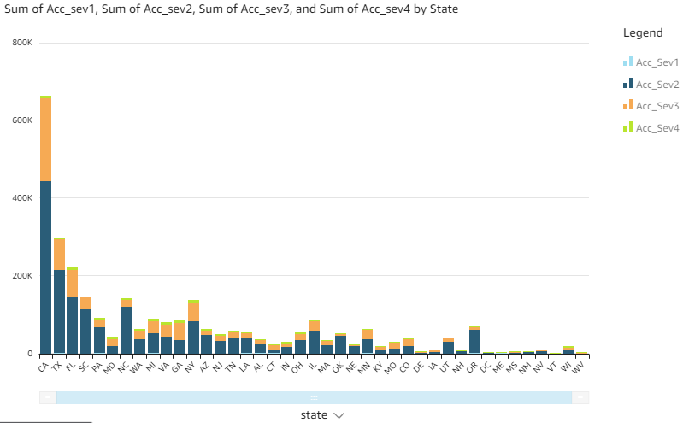

**Visualization 2:**

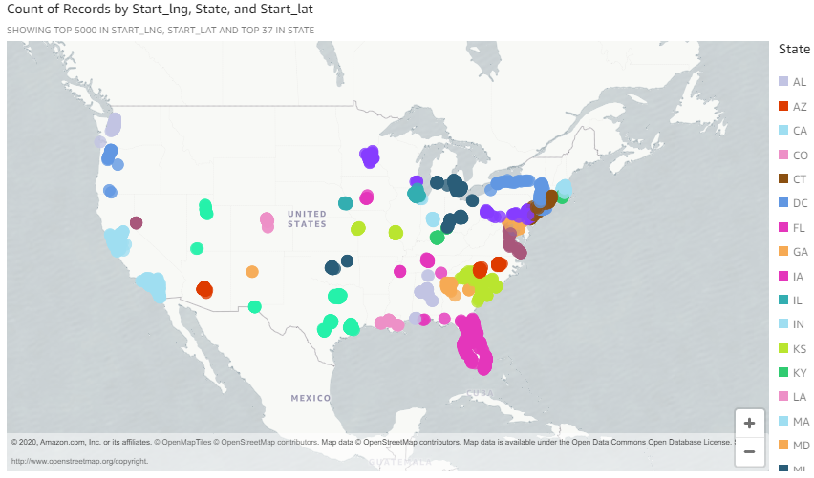

**Visualization 3:**

**SPICE:**

with cte AS (select

CASE

WHEN date_diff('minute', start_time, end_time)

BETWEEN 0

AND 59 THEN

'minutes'

WHEN date_diff('minute', start_time, end_time)

BETWEEN 60

AND 239 THEN

'hours'

WHEN date_diff('minute', start_time, end_time)

BETWEEN 240

AND 959 THEN

'4hours_16hours'

WHEN date_diff('minute', start_time, end_time)

BETWEEN 960

AND 1439 THEN

'16hours_24hours'

WHEN date_diff('minute', start_time, end_time) >= 1440 THEN

'days'

ELSE 'unknown'

END AS time_range, count(*) AS cnt

FROM us_accidents_dec_19_database.us_accident_v3

GROUP BY start_time, end_time)

SELECT time_range,

sum(cnt) AS count

FROM cte

GROUP BY time_range

ORDER BY count desc;

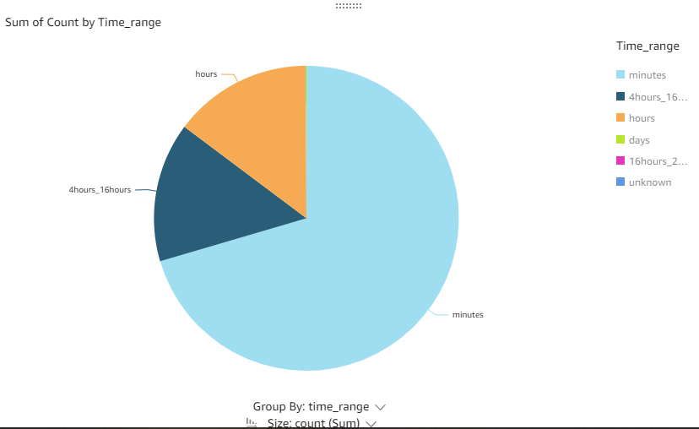

**Visualization 4:**

**SPICE (weather = ‘good’):**

WITH sev1 as

(SELECT DISTINCT count(id) AS Acc_Sev1,

weather_condition

FROM us_accidents_dec_19_database.us_accident_v3

WHERE severity = 1

AND (weather_condition LIKE 'Clear'

OR weather_condition LIKE 'Cloudy%'

OR weather_condition LIKE 'Drizzle'

OR weather_condition LIKE 'Drizzle / Windy'

OR weather_condition LIKE 'Fair%'

OR weather_condition LIKE 'Haze'

OR weather_condition LIKE 'Light%'

OR weather_condition LIKE 'Mist'

OR weather_condition LIKE 'Mostly%'

OR weather_condition LIKE 'N/A Precipitation'

OR weather_condition LIKE 'Overcast'

OR weather_condition LIKE 'Partial%'

OR weather_condition LIKE 'Partly%'

OR weather_condition LIKE 'Patches of Fog'

OR weather_condition LIKE 'Scattered Clouds'

OR weather_condition LIKE 'Shallow Fog'

OR weather_condition LIKE 'Showers IN the Vicinity'

OR weather_condition LIKE 'Small Hail'

OR weather_condition LIKE 'Thunder IN the Vicinity' )

GROUP BY weather_condition), sev2 as

(SELECT DISTINCT count(id) AS Acc_Sev2,

weather_condition

FROM us_accidents_dec_19_database.us_accident_v3

WHERE severity = 2

AND (weather_condition LIKE 'Clear'

OR weather_condition LIKE 'Cloudy%'

OR weather_condition LIKE 'Drizzle'

OR weather_condition LIKE 'Drizzle / Windy'

OR weather_condition LIKE 'Fair%'

OR weather_condition LIKE 'Haze'

OR weather_condition LIKE 'Light%'

OR weather_condition LIKE 'Mist'

OR weather_condition LIKE 'Mostly%'

OR weather_condition LIKE 'N/A Precipitation'

OR weather_condition LIKE 'Overcast'

OR weather_condition LIKE 'Partial%'

OR weather_condition LIKE 'Partly%'

OR weather_condition LIKE 'Patches of Fog'

OR weather_condition LIKE 'Scattered Clouds'

OR weather_condition LIKE 'Shallow Fog'

OR weather_condition LIKE 'Showers IN the Vicinity'

OR weather_condition LIKE 'Small Hail'

OR weather_condition LIKE 'Thunder IN the Vicinity' )

GROUP BY weather_condition), sev3 as

(SELECT DISTINCT count(id) AS Acc_Sev3,

weather_condition

FROM us_accidents_dec_19_database.us_accident_v3

WHERE severity = 3

AND (weather_condition LIKE 'Clear'

OR weather_condition LIKE 'Cloudy%'

OR weather_condition LIKE 'Drizzle'

OR weather_condition LIKE 'Drizzle / Windy'

OR weather_condition LIKE 'Fair%'

OR weather_condition LIKE 'Haze'

OR weather_condition LIKE 'Light%'

OR weather_condition LIKE 'Mist'

OR weather_condition LIKE 'Mostly%'

OR weather_condition LIKE 'N/A Precipitation'

OR weather_condition LIKE 'Overcast'

OR weather_condition LIKE 'Partial%'

OR weather_condition LIKE 'Partly%'

OR weather_condition LIKE 'Patches of Fog'

OR weather_condition LIKE 'Scattered Clouds'

OR weather_condition LIKE 'Shallow Fog'

OR weather_condition LIKE 'Showers IN the Vicinity'

OR weather_condition LIKE 'Small Hail'

OR weather_condition LIKE 'Thunder IN the Vicinity' )

GROUP BY weather_condition), sev4 as

(SELECT DISTINCT count(id) AS Acc_Sev4,

weather_condition

FROM us_accidents_dec_19_database.us_accident_v3

WHERE severity = 4

AND (weather_condition LIKE 'Clear'

OR weather_condition LIKE 'Cloudy%'

OR weather_condition LIKE 'Drizzle'

OR weather_condition LIKE 'Drizzle / Windy'

OR weather_condition LIKE 'Fair%'

OR weather_condition LIKE 'Haze'

OR weather_condition LIKE 'Light%'

OR weather_condition LIKE 'Mist'

OR weather_condition LIKE 'Mostly%'

OR weather_condition LIKE 'N/A Precipitation'

OR weather_condition LIKE 'Overcast'

OR weather_condition LIKE 'Partial%'

OR weather_condition LIKE 'Partly%'

OR weather_condition LIKE 'Patches of Fog'

OR weather_condition LIKE 'Scattered Clouds'

OR weather_condition LIKE 'Shallow Fog'

OR weather_condition LIKE 'Showers IN the Vicinity'

OR weather_condition LIKE 'Small Hail'

OR weather_condition LIKE 'Thunder IN the Vicinity' )

GROUP BY weather_condition)

SELECT sev1.weather_condition,

(cast(Acc_Sev1 AS double) / (Acc_Sev1+Acc_Sev2+Acc_Sev3+Acc_Sev4))*100 AS per_sev1,

(cast(Acc_Sev2 AS double) / (Acc_Sev1+Acc_Sev2+Acc_Sev3+Acc_Sev4))*100 AS per_sev2,

(cast(Acc_Sev3 AS double) / (Acc_Sev1+Acc_Sev2+Acc_Sev3+Acc_Sev4))*100 AS per_sev3,

(cast(Acc_Sev4 AS double) / (Acc_Sev1+Acc_Sev2+Acc_Sev3+Acc_Sev4))*100 AS per_sev4

FROM sev1, sev2, sev3, sev4

WHERE sev1.weather_condition = sev2.weather_condition

AND sev2.weather_condition = sev3.weather_condition

AND sev3.weather_condition = sev4.weather_condition

ORDER BY sev1.weather_condition ASC

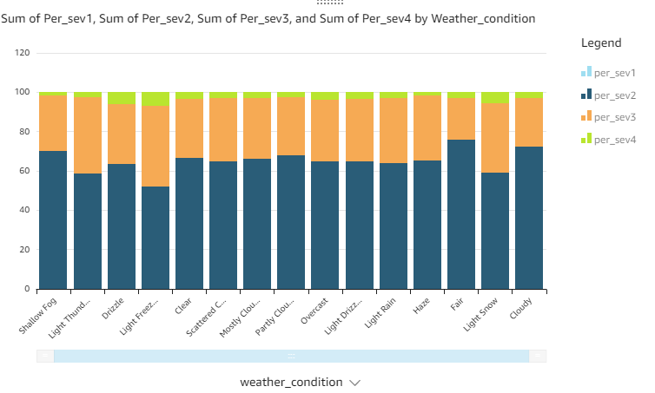

**SPICE (weather_condition = ‘bad’)**

WITH sev1 as

(SELECT DISTINCT count(id) AS Acc_Sev1,

weather_condition

FROM us_accidents_dec_19_database.us_accident_v3

WHERE severity = 1

AND (weather_condition LIKE 'Fog'

OR weather_condition LIKE 'Heavy Rain'

OR weather_condition LIKE 'Rain'

OR weather_condition LIKE 'Smoke'

OR weather_condition LIKE 'Snow'

OR weather_condition LIKE 'Thunder'

OR weather_condition LIKE 'Thunder in the Vicinity'

OR weather_condition LIKE 'Thunderstorm')

GROUP BY weather_condition), sev2 as

(SELECT DISTINCT count(id) AS Acc_Sev2,

weather_condition

FROM us_accidents_dec_19_database.us_accident_v3

WHERE severity = 2

AND (weather_condition LIKE 'Fog'

OR weather_condition LIKE 'Heavy Rain'

OR weather_condition LIKE 'Rain'

OR weather_condition LIKE 'Smoke'

OR weather_condition LIKE 'Snow'

OR weather_condition LIKE 'Thunder'

OR weather_condition LIKE 'Thunder in the Vicinity'

OR weather_condition LIKE 'Thunderstorm')

GROUP BY weather_condition), sev3 as

(SELECT DISTINCT count(id) AS Acc_Sev3,

weather_condition

FROM us_accidents_dec_19_database.us_accident_v3

WHERE severity = 3

AND (weather_condition LIKE 'Fog'

OR weather_condition LIKE 'Heavy Rain'

OR weather_condition LIKE 'Rain'

OR weather_condition LIKE 'Smoke'

OR weather_condition LIKE 'Snow'

OR weather_condition LIKE 'Thunder'

OR weather_condition LIKE 'Thunder in the Vicinity'

OR weather_condition LIKE 'Thunderstorm')

GROUP BY weather_condition), sev4 as

(SELECT DISTINCT count(id) AS Acc_Sev4,

weather_condition

FROM us_accidents_dec_19_database.us_accident_v3

WHERE severity = 4

AND (weather_condition LIKE 'Fog'

OR weather_condition LIKE 'Heavy Rain'

OR weather_condition LIKE 'Rain'

OR weather_condition LIKE 'Smoke'

OR weather_condition LIKE 'Snow'

OR weather_condition LIKE 'Thunder'

OR weather_condition LIKE 'Thunder in the Vicinity'

OR weather_condition LIKE 'Thunderstorm')

GROUP BY weather_condition)

SELECT sev1.weather_condition,

(cast(Acc_Sev1 AS double) / (Acc_Sev1+Acc_Sev2+Acc_Sev3+Acc_Sev4))*100 AS per_sev1,

(cast(Acc_Sev2 AS double) / (Acc_Sev1+Acc_Sev2+Acc_Sev3+Acc_Sev4))*100 AS per_sev2,

(cast(Acc_Sev3 AS double) / (Acc_Sev1+Acc_Sev2+Acc_Sev3+Acc_Sev4))*100 AS per_sev3,

(cast(Acc_Sev4 AS double) / (Acc_Sev1+Acc_Sev2+Acc_Sev3+Acc_Sev4))*100 AS per_sev4

FROM sev1, sev2, sev3, sev4

WHERE sev1.weather_condition = sev2.weather_condition

AND sev2.weather_condition = sev3.weather_condition

AND sev3.weather_condition = sev4.weather_condition

ORDER BY sev1.weather_condition ASC;

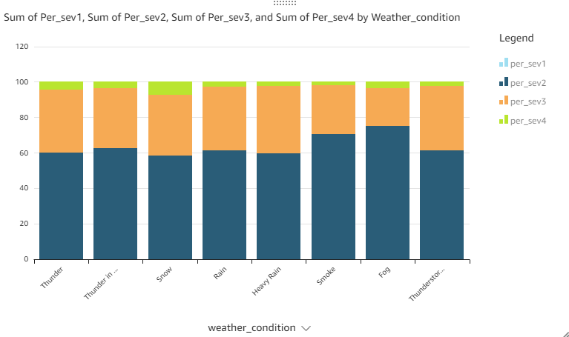

**Visualization 5:**

**Temperature**

**SPICE (weather_condition ‘good’):**

with cte1 as (select (year*100+month)*10+cast(range as integer) as yr_mt_temp, count(*) as count from

(select year(start_time) as year, month(start_time) as month,

case when temperature between -10 and 1 then '0'

when temperature between 2 and 13 then '1'

when temperature between 14 and 25 then '2'

when temperature between 26 and 37 then '3'

when temperature between 37 and 48 then '4'

when temperature between 49 and 61 then '5'

when temperature between 62 and 73 then '6'

when temperature between 74 and 85 then '7'

when temperature between 86 and 97 then '8'

when temperature between 98 and 109 then '9'

end as range, severity

from us_accidents_dec_19_database.us_accident_v3

where temperature between -10 and 109 and severity = 1 and (weather_condition not like 'Clear' or weather_condition not like 'Cloudy%' or weather_condition not like 'Drizzle' or weather_condition not like 'Drizzle / Windy' or weather_condition not like 'Fair%' or weather_condition not like 'Haze' or weather_condition not like 'Light%' or weather_condition not like 'Mist' or weather_condition not like 'Mostly%' or weather_condition not like 'N/A Precipitation' or weather_condition not like 'Overcast' or weather_condition not like 'Partial%' or weather_condition not like 'Partly%' or weather_condition not like 'Patches of Fog' or weather_condition not like 'Scattered Clouds' or weather_condition not like 'Shallow Fog' or weather_condition not like 'Showers in the Vicinity' or weather_condition not like 'Small Hail' or weather_condition not like 'Thunder in the Vicinity'

))

group by (year*100+month)*10+cast(range as integer), severity

order by (year*100+month)*10+cast(range as integer), severity),

cte2 as (select (year*100+month)*10+cast(range as integer) as yr_mt_temp, count(*) as count from

(select year(start_time) as year, month(start_time) as month,

case when temperature between -10 and 1 then '0'

when temperature between 2 and 13 then '1'

when temperature between 14 and 25 then '2'

when temperature between 26 and 37 then '3'

when temperature between 37 and 48 then '4'

when temperature between 49 and 61 then '5'

when temperature between 62 and 73 then '6'

when temperature between 74 and 85 then '7'

when temperature between 86 and 97 then '8'

when temperature between 98 and 109 then '9'

end as range, severity

from us_accidents_dec_19_database.us_accident_v3

where temperature between -10 and 109 and severity = 2 and (weather_condition not like 'Clear' or weather_condition not like 'Cloudy%' or weather_condition not like 'Drizzle' or weather_condition not like 'Drizzle / Windy' or weather_condition not like 'Fair%' or weather_condition not like 'Haze' or weather_condition not like 'Light%' or weather_condition not like 'Mist' or weather_condition not like 'Mostly%' or weather_condition not like 'N/A Precipitation' or weather_condition not like 'Overcast' or weather_condition not like 'Partial%' or weather_condition not like 'Partly%' or weather_condition not like 'Patches of Fog' or weather_condition not like 'Scattered Clouds' or weather_condition not like 'Shallow Fog' or weather_condition not like 'Showers in the Vicinity' or weather_condition not like 'Small Hail' or weather_condition not like 'Thunder in the Vicinity'

))

group by (year*100+month)*10+cast(range as integer), severity

order by (year*100+month)*10+cast(range as integer), severity),

cte3 as (select (year*100+month)*10+cast(range as integer) as yr_mt_temp, count(*) as count from

(select year(start_time) as year, month(start_time) as month,

case when temperature between -10 and 1 then '0'

when temperature between 2 and 13 then '1'

when temperature between 14 and 25 then '2'

when temperature between 26 and 37 then '3'

when temperature between 37 and 48 then '4'

when temperature between 49 and 61 then '5'

when temperature between 62 and 73 then '6'

when temperature between 74 and 85 then '7'

when temperature between 86 and 97 then '8'

when temperature between 98 and 109 then '9'

end as range, severity

from us_accidents_dec_19_database.us_accident_v3

where temperature between -10 and 109 and severity = 3 and (weather_condition not like 'Clear' or weather_condition not like 'Cloudy%' or weather_condition not like 'Drizzle' or weather_condition not like 'Drizzle / Windy' or weather_condition not like 'Fair%' or weather_condition not like 'Haze' or weather_condition not like 'Light%' or weather_condition not like 'Mist' or weather_condition not like 'Mostly%' or weather_condition not like 'N/A Precipitation' or weather_condition not like 'Overcast' or weather_condition not like 'Partial%' or weather_condition not like 'Partly%' or weather_condition not like 'Patches of Fog' or weather_condition not like 'Scattered Clouds' or weather_condition not like 'Shallow Fog' or weather_condition not like 'Showers in the Vicinity' or weather_condition not like 'Small Hail' or weather_condition not like 'Thunder in the Vicinity'

))

group by (year*100+month)*10+cast(range as integer), severity

order by (year*100+month)*10+cast(range as integer), severity),

cte4 as (select (year*100+month)*10+cast(range as integer) as yr_mt_temp, count(*) as count from

(select year(start_time) as year, month(start_time) as month,

case when temperature between -10 and 1 then '0'

when temperature between 2 and 13 then '1'

when temperature between 14 and 25 then '2'

when temperature between 26 and 37 then '3'

when temperature between 37 and 48 then '4'

when temperature between 49 and 61 then '5'

when temperature between 62 and 73 then '6'

when temperature between 74 and 85 then '7'

when temperature between 86 and 97 then '8'

when temperature between 98 and 109 then '9'

end as range, severity

from us_accidents_dec_19_database.us_accident_v3

where temperature between -10 and 109 and severity = 4 and (weather_condition not like 'Clear' or weather_condition not like 'Cloudy%' or weather_condition not like 'Drizzle' or weather_condition not like 'Drizzle / Windy' or weather_condition not like 'Fair%' or weather_condition not like 'Haze' or weather_condition not like 'Light%' or weather_condition not like 'Mist' or weather_condition not like 'Mostly%' or weather_condition not like 'N/A Precipitation' or weather_condition not like 'Overcast' or weather_condition not like 'Partial%' or weather_condition not like 'Partly%' or weather_condition not like 'Patches of Fog' or weather_condition not like 'Scattered Clouds' or weather_condition not like 'Shallow Fog' or weather_condition not like 'Showers in the Vicinity' or weather_condition not like 'Small Hail' or weather_condition not like 'Thunder in the Vicinity'

))

group by (year*100+month)*10+cast(range as integer), severity

order by (year*100+month)*10+cast(range as integer), severity)

select cte1.yr_mt_temp, cte1.count as sev1count, cte2.count as sev2count, cte3.count as sev3count, cte4.count as sev4count

from cte1, cte2, cte3, cte4

where cte1.yr_mt_temp = cte2.yr_mt_temp and cte2.yr_mt_temp = cte3.yr_mt_temp and cte3.yr_mt_temp = cte4.yr_mt_temp; 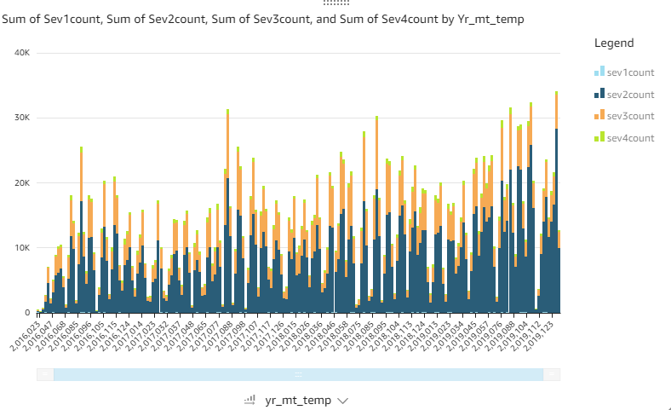

**SPICE (weather_condition ‘bad’):**

with cte1 as (select (year*100+month)*10+cast(range as integer) as yr_mt_temp, count(*) as count from

(select year(start_time) as year, month(start_time) as month,

case when temperature between -10 and 1 then '0'

when temperature between 2 and 13 then '1'

when temperature between 14 and 25 then '2'

when temperature between 26 and 37 then '3'

when temperature between 37 and 48 then '4'

when temperature between 49 and 61 then '5'

when temperature between 62 and 73 then '6'

when temperature between 74 and 85 then '7'

when temperature between 86 and 97 then '8'

when temperature between 98 and 109 then '9'

end as range, severity

from us_accidents_dec_19_database.us_accident_v3

where temperature between -10 and 109 and severity = 1 and (weather_condition not like 'Clear' and weather_condition not like 'Cloudy%' and weather_condition not like 'Drizzle' and weather_condition not like 'Drizzle / Windy' and weather_condition not like 'Fair%' and weather_condition not like 'Haze' and weather_condition not like 'Light%' and weather_condition not like 'Mist' and weather_condition not like 'Mostly%' and weather_condition not like 'N/A Precipitation' and weather_condition not like 'Overcast' and weather_condition not like 'Partial%' and weather_condition not like 'Partly%' and weather_condition not like 'Patches of Fog' and weather_condition not like 'Scattered Clouds' and weather_condition not like 'Shallow Fog' and weather_condition not like 'Showers in the Vicinity' and weather_condition not like 'Small Hail' and weather_condition not like 'Thunder in the Vicinity'

))

group by (year*100+month)*10+cast(range as integer), severity

order by (year*100+month)*10+cast(range as integer), severity),

cte2 as (select (year*100+month)*10+cast(range as integer) as yr_mt_temp, count(*) as count from

(select year(start_time) as year, month(start_time) as month,

case when temperature between -10 and 1 then '0'

when temperature between 2 and 13 then '1'

when temperature between 14 and 25 then '2'

when temperature between 26 and 37 then '3'

when temperature between 37 and 48 then '4'

when temperature between 49 and 61 then '5'

when temperature between 62 and 73 then '6'

when temperature between 74 and 85 then '7'

when temperature between 86 and 97 then '8'

when temperature between 98 and 109 then '9'

end as range, severity

from us_accidents_dec_19_database.us_accident_v3

where temperature between -10 and 109 and severity = 2 and (weather_condition not like 'Clear' and weather_condition not like 'Cloudy%' and weather_condition not like 'Drizzle' and weather_condition not like 'Drizzle / Windy' and weather_condition not like 'Fair%' and weather_condition not like 'Haze' and weather_condition not like 'Light%' and weather_condition not like 'Mist' and weather_condition not like 'Mostly%' and weather_condition not like 'N/A Precipitation' and weather_condition not like 'Overcast' and weather_condition not like 'Partial%' and weather_condition not like 'Partly%' and weather_condition not like 'Patches of Fog' and weather_condition not like 'Scattered Clouds' and weather_condition not like 'Shallow Fog' and weather_condition not like 'Showers in the Vicinity' and weather_condition not like 'Small Hail' and weather_condition not like 'Thunder in the Vicinity'

))

group by (year*100+month)*10+cast(range as integer), severity

order by (year*100+month)*10+cast(range as integer), severity),

cte3 as (select (year*100+month)*10+cast(range as integer) as yr_mt_temp, count(*) as count from

(select year(start_time) as year, month(start_time) as month,

case when temperature between -10 and 1 then '0'

when temperature between 2 and 13 then '1'

when temperature between 14 and 25 then '2'

when temperature between 26 and 37 then '3'

when temperature between 37 and 48 then '4'

when temperature between 49 and 61 then '5'

when temperature between 62 and 73 then '6'

when temperature between 74 and 85 then '7'

when temperature between 86 and 97 then '8'

when temperature between 98 and 109 then '9'

end as range, severity

from us_accidents_dec_19_database.us_accident_v3

where temperature between -10 and 109 and severity = 3 and (weather_condition not like 'Clear' and weather_condition not like 'Cloudy%' and weather_condition not like 'Drizzle' and weather_condition not like 'Drizzle / Windy' and weather_condition not like 'Fair%' and weather_condition not like 'Haze' and weather_condition not like 'Light%' and weather_condition not like 'Mist' and weather_condition not like 'Mostly%' and weather_condition not like 'N/A Precipitation' and weather_condition not like 'Overcast' and weather_condition not like 'Partial%' and weather_condition not like 'Partly%' and weather_condition not like 'Patches of Fog' and weather_condition not like 'Scattered Clouds' and weather_condition not like 'Shallow Fog' and weather_condition not like 'Showers in the Vicinity' and weather_condition not like 'Small Hail' and weather_condition not like 'Thunder in the Vicinity'

))

group by (year*100+month)*10+cast(range as integer), severity

order by (year*100+month)*10+cast(range as integer), severity),

cte4 as (select (year*100+month)*10+cast(range as integer) as yr_mt_temp, count(*) as count from

(select year(start_time) as year, month(start_time) as month,

case when temperature between -10 and 1 then '0'

when temperature between 2 and 13 then '1'

when temperature between 14 and 25 then '2'

when temperature between 26 and 37 then '3'

when temperature between 37 and 48 then '4'

when temperature between 49 and 61 then '5'

when temperature between 62 and 73 then '6'

when temperature between 74 and 85 then '7'

when temperature between 86 and 97 then '8'

when temperature between 98 and 109 then '9'

end as range, severity

from us_accidents_dec_19_database.us_accident_v3

where temperature between -10 and 109 and severity = 4 and (weather_condition not like 'Clear' and weather_condition not like 'Cloudy%' and weather_condition not like 'Drizzle' and weather_condition not like 'Drizzle / Windy' and weather_condition not like 'Fair%' and weather_condition not like 'Haze' and weather_condition not like 'Light%' and weather_condition not like 'Mist' and weather_condition not like 'Mostly%' and weather_condition not like 'N/A Precipitation' and weather_condition not like 'Overcast' and weather_condition not like 'Partial%' and weather_condition not like 'Partly%' and weather_condition not like 'Patches of Fog' and weather_condition not like 'Scattered Clouds' and weather_condition not like 'Shallow Fog' and weather_condition not like 'Showers in the Vicinity' and weather_condition not like 'Small Hail' and weather_condition not like 'Thunder in the Vicinity'

))

group by (year*100+month)*10+cast(range as integer), severity

order by (year*100+month)*10+cast(range as integer), severity)

select cte1.yr_mt_temp, cte1.count as sev1count, cte2.count as sev2count, cte3.count as sev3count, cte4.count as sev4count

from cte1, cte2, cte3, cte4

where cte1.yr_mt_temp = cte2.yr_mt_temp and cte2.yr_mt_temp = cte3.yr_mt_temp and cte3.yr_mt_temp = cte4.yr_mt_temp;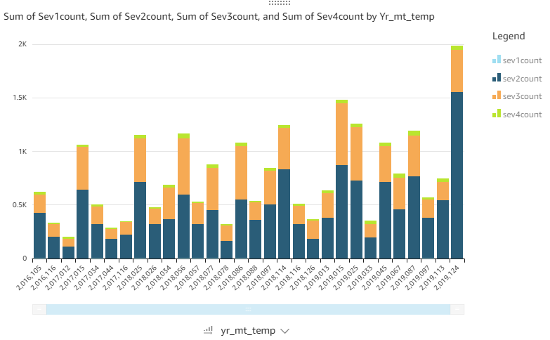

**Visibility**

**SPICE (weather_condition ‘good’):**

**SPICE (weather_condition ‘bad’):**

**Wind Speed**

**SPICE (weather_condition ‘good’):**

**SPICE (weather_condition ‘bad’):**

**Traffic Signal**

**SPICE (weather_condition ‘good’):**

with cte1 as (select (year*100+month)*10+cast(range as integer) as yr_mt_traff, count(*) as count from

(select year(start_time) as year, month(start_time) as month,

case when traffic_signal = false then '0'

when traffic_signal = true then '1'

end as range, severity

from us_accidents_dec_19_database.us_accident_v3

where severity = 1 and (weather_condition like 'Clear' or weather_condition like 'Cloudy%' or weather_condition like 'Drizzle' or weather_condition like 'Drizzle / Windy' or weather_condition like 'Fair%' or weather_condition like 'Haze' or weather_condition like 'Light%' or weather_condition like 'Mist' or weather_condition like 'Mostly%' or weather_condition like 'N/A Precipitation' or weather_condition like 'Overcast' or weather_condition like 'Partial%' or weather_condition like 'Partly%' or weather_condition like 'Patches of Fog' or weather_condition like 'Scattered Clouds' or weather_condition like 'Shallow Fog' or weather_condition like 'Showers in the Vicinity' or weather_condition like 'Small Hail' or weather_condition like 'Thunder in the Vicinity'

))

group by (year*100+month)*10+cast(range as integer), severity

order by (year*100+month)*10+cast(range as integer), severity),

cte2 as (select (year*100+month)*10+cast(range as integer) as yr_mt_traff, count(*) as count from

(select year(start_time) as year, month(start_time) as month,

case when traffic_signal = false then '0'

when traffic_signal = true then '1'

end as range, severity

from us_accidents_dec_19_database.us_accident_v3

where severity = 2 and (weather_condition like 'Clear' or weather_condition like 'Cloudy%' or weather_condition like 'Drizzle' or weather_condition like 'Drizzle / Windy' or weather_condition like 'Fair%' or weather_condition like 'Haze' or weather_condition like 'Light%' or weather_condition like 'Mist' or weather_condition like 'Mostly%' or weather_condition like 'N/A Precipitation' or weather_condition like 'Overcast' or weather_condition like 'Partial%' or weather_condition like 'Partly%' or weather_condition like 'Patches of Fog' or weather_condition like 'Scattered Clouds' or weather_condition like 'Shallow Fog' or weather_condition like 'Showers in the Vicinity' or weather_condition like 'Small Hail' or weather_condition like 'Thunder in the Vicinity'

))

group by (year*100+month)*10+cast(range as integer), severity

order by (year*100+month)*10+cast(range as integer), severity),

cte3 as (select (year*100+month)*10+cast(range as integer) as yr_mt_traff, count(*) as count from

(select year(start_time) as year, month(start_time) as month,

case when traffic_signal = false then '0'

when traffic_signal = true then '1'

end as range, severity

from us_accidents_dec_19_database.us_accident_v3

where severity = 3 and (weather_condition like 'Clear' or weather_condition like 'Cloudy%' or weather_condition like 'Drizzle' or weather_condition like 'Drizzle / Windy' or weather_condition like 'Fair%' or weather_condition like 'Haze' or weather_condition like 'Light%' or weather_condition like 'Mist' or weather_condition like 'Mostly%' or weather_condition like 'N/A Precipitation' or weather_condition like 'Overcast' or weather_condition like 'Partial%' or weather_condition like 'Partly%' or weather_condition like 'Patches of Fog' or weather_condition like 'Scattered Clouds' or weather_condition like 'Shallow Fog' or weather_condition like 'Showers in the Vicinity' or weather_condition like 'Small Hail' or weather_condition like 'Thunder in the Vicinity'

))

group by (year*100+month)*10+cast(range as integer), severity

order by (year*100+month)*10+cast(range as integer), severity),

cte4 as (select (year*100+month)*10+cast(range as integer) as yr_mt_traff, count(*) as count from

(select year(start_time) as year, month(start_time) as month,

case when traffic_signal = false then '0'

when traffic_signal = true then '1'

end as range, severity

from us_accidents_dec_19_database.us_accident_v3

where severity = 4 and (weather_condition like 'Clear' or weather_condition like 'Cloudy%' or weather_condition like 'Drizzle' or weather_condition like 'Drizzle / Windy' or weather_condition like 'Fair%' or weather_condition like 'Haze' or weather_condition like 'Light%' or weather_condition like 'Mist' or weather_condition like 'Mostly%' or weather_condition like 'N/A Precipitation' or weather_condition like 'Overcast' or weather_condition like 'Partial%' or weather_condition like 'Partly%' or weather_condition like 'Patches of Fog' or weather_condition like 'Scattered Clouds' or weather_condition like 'Shallow Fog' or weather_condition like 'Showers in the Vicinity' or weather_condition like 'Small Hail' or weather_condition like 'Thunder in the Vicinity'

))

group by (year*100+month)*10+cast(range as integer), severity

order by (year*100+month)*10+cast(range as integer), severity)

select cte1.yr_mt_traff, cte1.count as sev1count, cte2.count as sev2count, cte3.count as sev3count, cte4.count as sev4count

from cte1, cte2, cte3, cte4

where cte1.yr_mt_traff = cte2.yr_mt_traff and cte2.yr_mt_traff = cte3.yr_mt_traff and cte3.yr_mt_traff = cte4.yr_mt_traff;

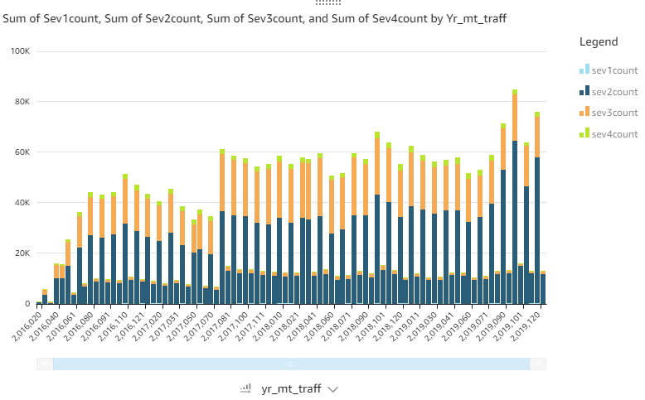

**SPICE (weather_condition ‘bad’):**

with cte1 as (select (year*100+month)*10+cast(range as integer) as yr_mt_traff, count(*) as count from

(select year(start_time) as year, month(start_time) as month,

case when traffic_signal = false then '0'

when traffic_signal = true then '1'

end as range, severity

from us_accidents_dec_19_database.us_accident_v3

where severity = 1 and (weather_condition not like 'Clear' and weather_condition not like 'Cloudy%' and weather_condition not like 'Drizzle' and weather_condition not like 'Drizzle / Windy' and weather_condition not like 'Fair%' and weather_condition not like 'Haze' and weather_condition not like 'Light%' and weather_condition not like 'Mist' and weather_condition not like 'Mostly%' and weather_condition not like 'N/A Precipitation' and weather_condition not like 'Overcast' and weather_condition not like 'Partial%' and weather_condition not like 'Partly%' and weather_condition not like 'Patches of Fog' and weather_condition not like 'Scattered Clouds' and weather_condition not like 'Shallow Fog' and weather_condition not like 'Showers in the Vicinity' and weather_condition not like 'Small Hail' and weather_condition not like 'Thunder in the Vicinity'

))

group by (year*100+month)*10+cast(range as integer), severity

order by (year*100+month)*10+cast(range as integer), severity),

cte2 as (select (year*100+month)*10+cast(range as integer) as yr_mt_traff, count(*) as count from

(select year(start_time) as year, month(start_time) as month,

case when traffic_signal = false then '0'

when traffic_signal = true then '1'

end as range, severity

from us_accidents_dec_19_database.us_accident_v3

where severity = 2 and (weather_condition not like 'Clear' and weather_condition not like 'Cloudy%' and weather_condition not like 'Drizzle' and weather_condition not like 'Drizzle / Windy' and weather_condition not like 'Fair%' and weather_condition not like 'Haze' and weather_condition not like 'Light%' and weather_condition not like 'Mist' and weather_condition not like 'Mostly%' and weather_condition not like 'N/A Precipitation' and weather_condition not like 'Overcast' and weather_condition not like 'Partial%' and weather_condition not like 'Partly%' and weather_condition not like 'Patches of Fog' and weather_condition not like 'Scattered Clouds' and weather_condition not like 'Shallow Fog' and weather_condition not like 'Showers in the Vicinity' and weather_condition not like 'Small Hail' and weather_condition not like 'Thunder in the Vicinity'

))

group by (year*100+month)*10+cast(range as integer), severity

order by (year*100+month)*10+cast(range as integer), severity),

cte3 as (select (year*100+month)*10+cast(range as integer) as yr_mt_traff, count(*) as count from

(select year(start_time) as year, month(start_time) as month,

case when traffic_signal = false then '0'

when traffic_signal = true then '1'

end as range, severity

from us_accidents_dec_19_database.us_accident_v3

where severity = 3 and (weather_condition not like 'Clear' and weather_condition not like 'Cloudy%' and weather_condition not like 'Drizzle' and weather_condition not like 'Drizzle / Windy' and weather_condition not like 'Fair%' and weather_condition not like 'Haze' and weather_condition not like 'Light%' and weather_condition not like 'Mist' and weather_condition not like 'Mostly%' and weather_condition not like 'N/A Precipitation' and weather_condition not like 'Overcast' and weather_condition not like 'Partial%' and weather_condition not like 'Partly%' and weather_condition not like 'Patches of Fog' and weather_condition not like 'Scattered Clouds' and weather_condition not like 'Shallow Fog' and weather_condition not like 'Showers in the Vicinity' and weather_condition not like 'Small Hail' and weather_condition not like 'Thunder in the Vicinity'

))

group by (year*100+month)*10+cast(range as integer), severity

order by (year*100+month)*10+cast(range as integer), severity),

cte4 as (select (year*100+month)*10+cast(range as integer) as yr_mt_traff, count(*) as count from

(select year(start_time) as year, month(start_time) as month,

case when traffic_signal = false then '0'

when traffic_signal = true then '1'

end as range, severity

from us_accidents_dec_19_database.us_accident_v3

where severity = 4 and (weather_condition not like 'Clear' and weather_condition not like 'Cloudy%' and weather_condition not like 'Drizzle' and weather_condition not like 'Drizzle / Windy' and weather_condition not like 'Fair%' and weather_condition not like 'Haze' and weather_condition not like 'Light%' and weather_condition not like 'Mist' and weather_condition not like 'Mostly%' and weather_condition not like 'N/A Precipitation' and weather_condition not like 'Overcast' and weather_condition not like 'Partial%' and weather_condition not like 'Partly%' and weather_condition not like 'Patches of Fog' and weather_condition not like 'Scattered Clouds' and weather_condition not like 'Shallow Fog' and weather_condition not like 'Showers in the Vicinity' and weather_condition not like 'Small Hail' and weather_condition not like 'Thunder in the Vicinity'

))

group by (year*100+month)*10+cast(range as integer), severity

order by (year*100+month)*10+cast(range as integer), severity)

select cte1.yr_mt_traff, cte1.count as sev1count, cte2.count as sev2count, cte3.count as sev3count, cte4.count as sev4count

from cte1, cte2, cte3, cte4

where cte1.yr_mt_traff = cte2.yr_mt_traff and cte2.yr_mt_traff = cte3.yr_mt_traff and cte3.yr_mt_traff = cte4.yr_mt_traff;

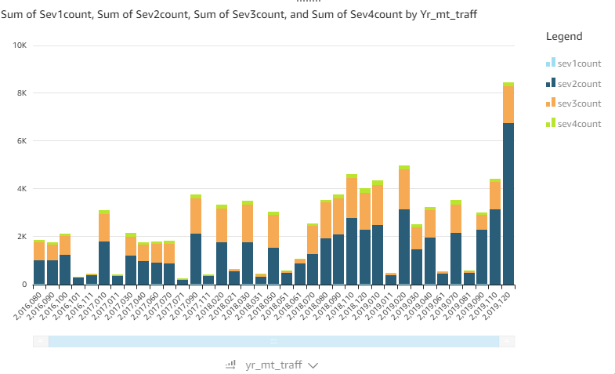

**Crossing**

**SPICE (weather_condition ‘good’):**

with cte1 as (select (year*100+month)*10+cast(range as integer) as yr_mt_cross, count(*) as count from

(select year(start_time) as year, month(start_time) as month,

case when crossing = false then '0'

when crossing = true then '1'

end as range, severity

from us_accidents_dec_19_database.us_accident_v3

where severity = 1 and (weather_condition like 'Clear' or weather_condition like 'Cloudy%' or weather_condition like 'Drizzle' or weather_condition like 'Drizzle / Windy' or weather_condition like 'Fair%' or weather_condition like 'Haze' or weather_condition like 'Light%' or weather_condition like 'Mist' or weather_condition like 'Mostly%' or weather_condition like 'N/A Precipitation' or weather_condition like 'Overcast' or weather_condition like 'Partial%' or weather_condition like 'Partly%' or weather_condition like 'Patches of Fog' or weather_condition like 'Scattered Clouds' or weather_condition like 'Shallow Fog' or weather_condition like 'Showers in the Vicinity' or weather_condition like 'Small Hail' or weather_condition like 'Thunder in the Vicinity'

))

group by (year*100+month)*10+cast(range as integer), severity

order by (year*100+month)*10+cast(range as integer), severity),

cte2 as (select (year*100+month)*10+cast(range as integer) as yr_mt_cross, count(*) as count from

(select year(start_time) as year, month(start_time) as month,

case when crossing = false then '0'

when crossing = true then '1'

end as range, severity

from us_accidents_dec_19_database.us_accident_v3

where severity = 2 and (weather_condition like 'Clear' or weather_condition like 'Cloudy%' or weather_condition like 'Drizzle' or weather_condition like 'Drizzle / Windy' or weather_condition like 'Fair%' or weather_condition like 'Haze' or weather_condition like 'Light%' or weather_condition like 'Mist' or weather_condition like 'Mostly%' or weather_condition like 'N/A Precipitation' or weather_condition like 'Overcast' or weather_condition like 'Partial%' or weather_condition like 'Partly%' or weather_condition like 'Patches of Fog' or weather_condition like 'Scattered Clouds' or weather_condition like 'Shallow Fog' or weather_condition like 'Showers in the Vicinity' or weather_condition like 'Small Hail' or weather_condition like 'Thunder in the Vicinity'

))

group by (year*100+month)*10+cast(range as integer), severity

order by (year*100+month)*10+cast(range as integer), severity),

cte3 as (select (year*100+month)*10+cast(range as integer) as yr_mt_cross, count(*) as count from

(select year(start_time) as year, month(start_time) as month,

case when crossing = false then '0'

when crossing = true then '1'

end as range, severity

from us_accidents_dec_19_database.us_accident_v3

where severity = 3 and (weather_condition like 'Clear' or weather_condition like 'Cloudy%' or weather_condition like 'Drizzle' or weather_condition like 'Drizzle / Windy' or weather_condition like 'Fair%' or weather_condition like 'Haze' or weather_condition like 'Light%' or weather_condition like 'Mist' or weather_condition like 'Mostly%' or weather_condition like 'N/A Precipitation' or weather_condition like 'Overcast' or weather_condition like 'Partial%' or weather_condition like 'Partly%' or weather_condition like 'Patches of Fog' or weather_condition like 'Scattered Clouds' or weather_condition like 'Shallow Fog' or weather_condition like 'Showers in the Vicinity' or weather_condition like 'Small Hail' or weather_condition like 'Thunder in the Vicinity'

))

group by (year*100+month)*10+cast(range as integer), severity

order by (year*100+month)*10+cast(range as integer), severity),

cte4 as (select (year*100+month)*10+cast(range as integer) as yr_mt_cross, count(*) as count from

(select year(start_time) as year, month(start_time) as month,

case when crossing = false then '0'

when crossing = true then '1'

end as range, severity

from us_accidents_dec_19_database.us_accident_v3

where severity = 4 and (weather_condition like 'Clear' or weather_condition like 'Cloudy%' or weather_condition like 'Drizzle' or weather_condition like 'Drizzle / Windy' or weather_condition like 'Fair%' or weather_condition like 'Haze' or weather_condition like 'Light%' or weather_condition like 'Mist' or weather_condition like 'Mostly%' or weather_condition like 'N/A Precipitation' or weather_condition like 'Overcast' or weather_condition like 'Partial%' or weather_condition like 'Partly%' or weather_condition like 'Patches of Fog' or weather_condition like 'Scattered Clouds' or weather_condition like 'Shallow Fog' or weather_condition like 'Showers in the Vicinity' or weather_condition like 'Small Hail' or weather_condition like 'Thunder in the Vicinity'

))

group by (year*100+month)*10+cast(range as integer), severity

order by (year*100+month)*10+cast(range as integer), severity)

select cte1.yr_mt_cross, cte1.count as sev1count, cte2.count as sev2count, cte3.count as sev3count, cte4.count as sev4count

from cte1, cte2, cte3, cte4

where cte1.yr_mt_cross = cte2.yr_mt_cross and cte2.yr_mt_cross = cte3.yr_mt_cross and cte3.yr_mt_cross = cte4.yr_mt_cross;

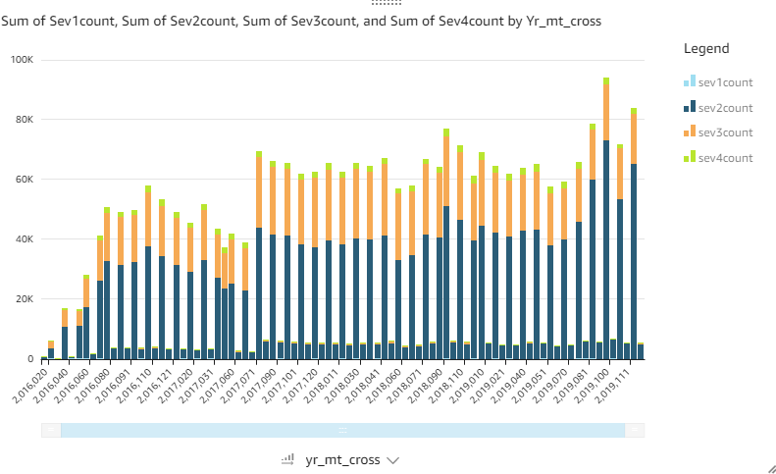

**SPICE (weather_condition ‘bad’):**

with cte1 as (select (year*100+month)*10+cast(range as integer) as yr_mt_cross, count(*) as count from

(select year(start_time) as year, month(start_time) as month,

case when crossing = false then '0'

when crossing = true then '1'

end as range, severity

from us_accidents_dec_19_database.us_accident_v3

where severity = 1 and (weather_condition not like 'Clear' and weather_condition not like 'Cloudy%' and weather_condition not like 'Drizzle' and weather_condition not like 'Drizzle / Windy' and weather_condition not like 'Fair%' and weather_condition not like 'Haze' and weather_condition not like 'Light%' and weather_condition not like 'Mist' and weather_condition not like 'Mostly%' and weather_condition not like 'N/A Precipitation' and weather_condition not like 'Overcast' and weather_condition not like 'Partial%' and weather_condition not like 'Partly%' and weather_condition not like 'Patches of Fog' and weather_condition not like 'Scattered Clouds' and weather_condition not like 'Shallow Fog' and weather_condition not like 'Showers in the Vicinity' and weather_condition not like 'Small Hail' and weather_condition not like 'Thunder in the Vicinity'

))

group by (year*100+month)*10+cast(range as integer), severity

order by (year*100+month)*10+cast(range as integer), severity),

cte2 as (select (year*100+month)*10+cast(range as integer) as yr_mt_cross, count(*) as count from

(select year(start_time) as year, month(start_time) as month,

case when crossing = false then '0'

when crossing = true then '1'

end as range, severity

from us_accidents_dec_19_database.us_accident_v3

where severity = 2 and (weather_condition not like 'Clear' and weather_condition not like 'Cloudy%' and weather_condition not like 'Drizzle' and weather_condition not like 'Drizzle / Windy' and weather_condition not like 'Fair%' and weather_condition not like 'Haze' and weather_condition not like 'Light%' and weather_condition not like 'Mist' and weather_condition not like 'Mostly%' and weather_condition not like 'N/A Precipitation' and weather_condition not like 'Overcast' and weather_condition not like 'Partial%' and weather_condition not like 'Partly%' and weather_condition not like 'Patches of Fog' and weather_condition not like 'Scattered Clouds' and weather_condition not like 'Shallow Fog' and weather_condition not like 'Showers in the Vicinity' and weather_condition not like 'Small Hail' and weather_condition not like 'Thunder in the Vicinity'

))

group by (year*100+month)*10+cast(range as integer), severity

order by (year*100+month)*10+cast(range as integer), severity),

cte3 as (select (year*100+month)*10+cast(range as integer) as yr_mt_cross, count(*) as count from

(select year(start_time) as year, month(start_time) as month,

case when crossing = false then '0'

when crossing = true then '1'

end as range, severity

from us_accidents_dec_19_database.us_accident_v3

where severity = 3 and (weather_condition not like 'Clear' and weather_condition not like 'Cloudy%' and weather_condition not like 'Drizzle' and weather_condition not like 'Drizzle / Windy' and weather_condition not like 'Fair%' and weather_condition not like 'Haze' and weather_condition not like 'Light%' and weather_condition not like 'Mist' and weather_condition not like 'Mostly%' and weather_condition not like 'N/A Precipitation' and weather_condition not like 'Overcast' and weather_condition not like 'Partial%' and weather_condition not like 'Partly%' and weather_condition not like 'Patches of Fog' and weather_condition not like 'Scattered Clouds' and weather_condition not like 'Shallow Fog' and weather_condition not like 'Showers in the Vicinity' and weather_condition not like 'Small Hail' and weather_condition not like 'Thunder in the Vicinity'

))

group by (year*100+month)*10+cast(range as integer), severity

order by (year*100+month)*10+cast(range as integer), severity),

cte4 as (select (year*100+month)*10+cast(range as integer) as yr_mt_cross, count(*) as count from

(select year(start_time) as year, month(start_time) as month,

case when crossing = false then '0'

when crossing = true then '1'

end as range, severity

from us_accidents_dec_19_database.us_accident_v3

where severity = 4 and (weather_condition not like 'Clear' and weather_condition not like 'Cloudy%' and weather_condition not like 'Drizzle' and weather_condition not like 'Drizzle / Windy' and weather_condition not like 'Fair%' and weather_condition not like 'Haze' and weather_condition not like 'Light%' and weather_condition not like 'Mist' and weather_condition not like 'Mostly%' and weather_condition not like 'N/A Precipitation' and weather_condition not like 'Overcast' and weather_condition not like 'Partial%' and weather_condition not like 'Partly%' and weather_condition not like 'Patches of Fog' and weather_condition not like 'Scattered Clouds' and weather_condition not like 'Shallow Fog' and weather_condition not like 'Showers in the Vicinity' and weather_condition not like 'Small Hail' and weather_condition not like 'Thunder in the Vicinity'

))

group by (year*100+month)*10+cast(range as integer), severity

order by (year*100+month)*10+cast(range as integer), severity)

select cte1.yr_mt_cross, cte1.count as sev1count, cte2.count as sev2count, cte3.count as sev3count, cte4.count as sev4count

from cte1, cte2, cte3, cte4

where cte1.yr_mt_cross = cte2.yr_mt_cross and cte2.yr_mt_cross = cte3.yr_mt_cross and cte3.yr_mt_cross = cte4.yr_mt_cross; 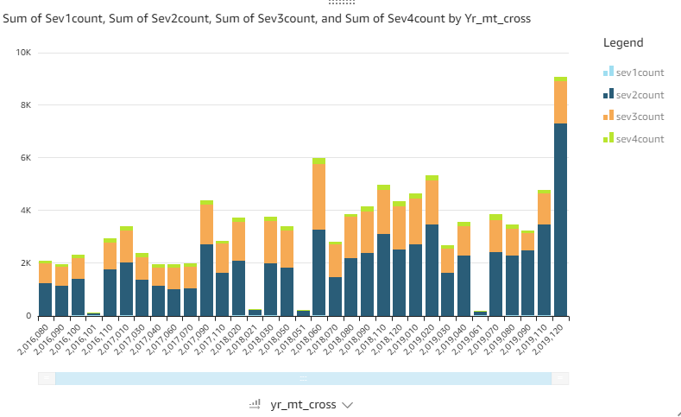

**Junction**

**SPICE (weather_condition ‘good’):**

**SPICE (weather_condition ‘bad’):**

**Visualization 6:**

**SPICE:**

SELECT date_format(start_time,

'%Y, %v') AS yr_wk , severity, count(*) AS Total_accidents

FROM us_accidents_dec_19_database.us_accident_v3

GROUP BY start_time, severity;

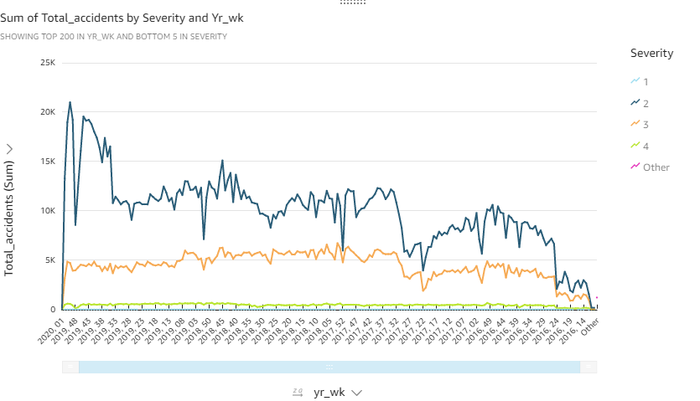

**Visualization 7:**

Stddev and Avg:

**SPICE:**

SELECT DISTINCT severity,

avg(distance)

OVER (partition by severity) as avg, stddev(distance)

OVER (partition by severity) as stddev

FROM us_accidents_dec_19_database.us_accident_v3;

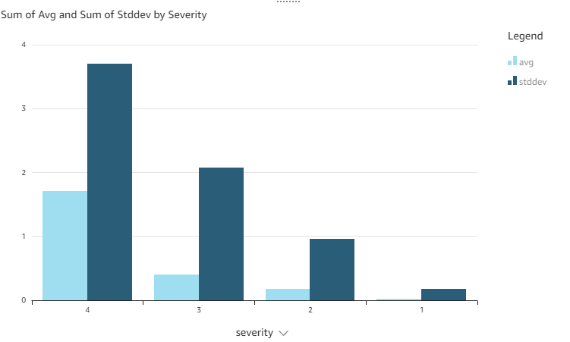

Max:

**SPICE:**

SELECT DISTINCT severity,

max(distance)

OVER (partition by severity) as max

FROM us_accidents_dec_19_database.us_accident_v3;

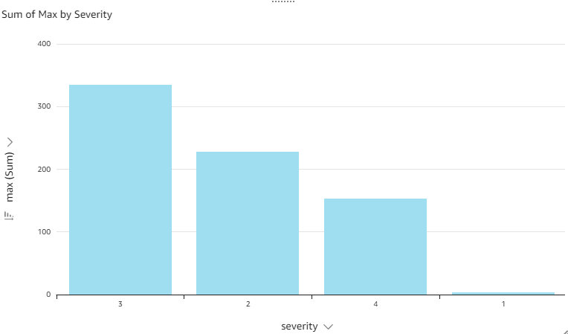

**Visualization 10:**

**SPICE:**

select Concept, sum(Frequency) as Freq from (with cte1 AS

(SELECT b.slno,

b.pattrn,

b.concpt,

cardinality(regexp_extract_all(lower(a.n_description),

lower(b.pattrn))) count

FROM base_corpus3 a

CROSS JOIN concept7 b

ORDER BY slno)

SELECT DISTINCT slno AS Serial_No,

concpt AS Concept,

pattrn AS Pattern,

sum(count)

OVER (partition by pattrn) AS Frequency

FROM cte1

ORDER BY slno) group by Concept;

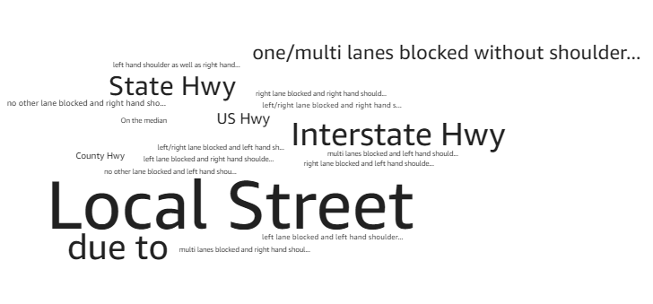

**Visualization 13:**

**SPICE:**

SELECT DISTINCT state,

date,

avg(sum_precip)

OVER (partition by date, state) AS avg_precip2

FROM

(SELECT DISTINCT state,

zipcode,

date,

sum(avg_precip)

OVER (partition by date, zipcode, state) AS sum_precip

FROM

(SELECT DISTINCT state,

zipcode,

date(start_time) AS date,

hour(start_time) AS hour,

minute(start_time) AS minute,

count(*) AS count,

avg(precipitation) AS avg_precip

FROM us_accidents_dec_19_database.us_accident_v3

GROUP BY state, zipcode, date(start_time), hour(start_time), minute(start_time)

ORDER BY count desc)

ORDER BY state, zipcode, date)

WHERE state = 'NY'

OR state = 'NJ'

OR state = 'PA'or state = 'IN'

OR state = 'WY'

ORDER BY state, date;

